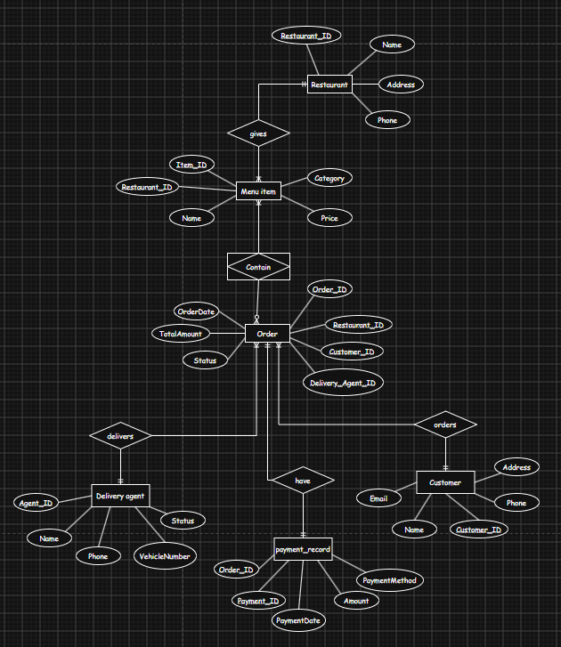
Q01.

Q02.
Create database--------
CREATE DATABASE HotelReservationSystem;
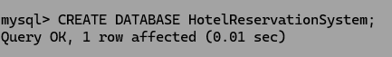
Use database---------------
USE HotelReservationSystem;

Create table Hotel-----------------
CREATE TABLE Hotel (
-> hotel_id INT PRIMARY KEY,
-> hotel_name VARCHAR(100),
-> city VARCHAR(50),
-> star_rating INT
-> );
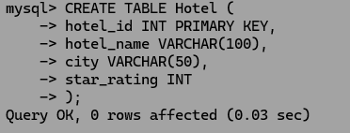

Create table Room-----------
CREATE TABLE Room(
-> room_id INT PRIMARY KEY,
-> hotel_id INT,
-> room_number VARCHAR(10),
-> room_type VARCHAR(20),
-> price_per_night DECIMAL(10,2),
-> FOREIGN KEY (hotel_id) REFERENCES Hotel (hotel_id)
-> );
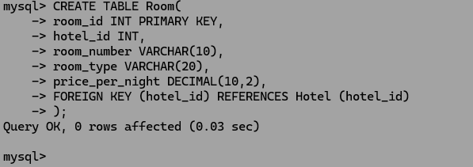

Create table Guest-----------
CREATE TABLE Guest(
-> guest_id INT PRIMARY KEY,
-> first_name VARCHAR(50),
-> last_name VARCHAR(50),
-> email VARCHAR(100) UNIQUE,
-> phone VARCHAR(15)
-> );
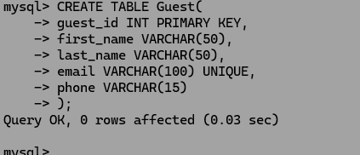

Create table Resrevation----------
CREATE TABLE Reservation(
-> reservation_id INT PRIMARY KEY,
-> room_id INT,
-> guest_id INT,
-> check_in DATE,
-> check_out DATE,
-> FOREIGN KEY (room_id) REFERENCES Room (room_id),
-> FOREIGN KEY (guest_id) REFERENCES Guest (guest_id)
-> );
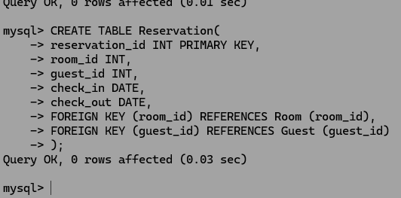

Create table payment-----------

CREATE TABLE Payment(
-> payment_id INT PRIMARY KEY,
-> reservation_id INT,
-> amount DECIMAL(10,2),
-> payment_date DATE,
-> payment_method VARCHAR(20),
-> FOREIGN KEY (reservation_id) REFERENCES Reservation (reservation_id)
-> );

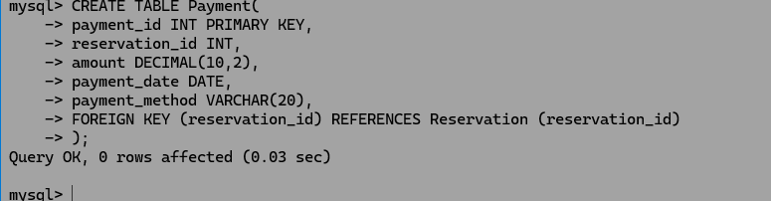

Insert value to table----
|
V

Hotel table. ----

INSERT INTO Hotel VALUES
-> (1,'Grand Palace','Colombo',5),
-> (2,'Ocean View','Galle',4),
-> (3,'Mountain Retreat','Kandy',3),
-> (4,'City Comfort','Colombo',4),
-> (5,'Beachside Inn','Negombo',3);

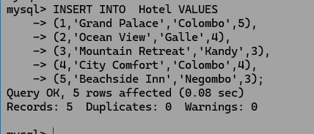

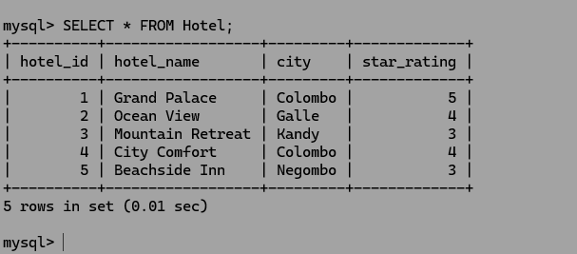

Room table. ----

INSERT INTO Room VALUES
-> (1,1,'101','Deluxe',150.00),
-> (2,1,'102','Suite',250.00),
-> (3,2,'201','Standard',90.00),
-> (4,3,'301','Deluxe',120.00),
-> (5,4,'401','Standard',80.00);

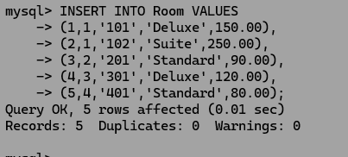

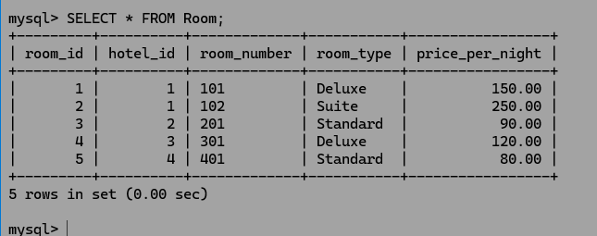

Guest table. ----

INSERT INTO Guest VALUES
-> (1,'John','Fernando','john.f@example.com','0771234567'),
-> (2,'Emily','Silva','emily.silva@example.com','0719876543'),
-> (3,'Carlos','Perera','carlos.perera@example.com','0765554433'),
-> (4,'Aisha','Khan','aisha.khan@example.com','0752223344'),
-> (5,'Luca','Rathnayake','luca.r@example.com','0788889999');

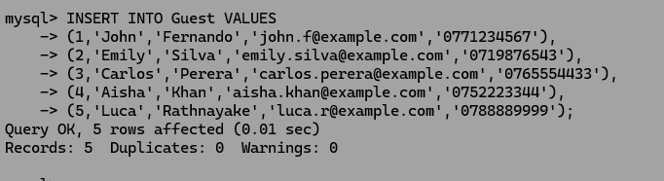

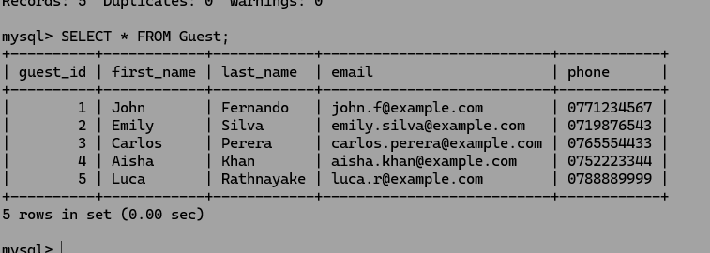

Reservation table---------

INSERT INTO Reservation VALUES
-> (1,1,1,'2026-09-01','2026-09-05'),
-> (2,2,2,'2026-09-10','2026-09-12'),
-> (3,3,3,'2026-09-15','2026-09-18'),
-> (4,4,4,'2026-09-20','2026-09-22'),
-> (5,5,5,'2026-09-25','2026-09-28');

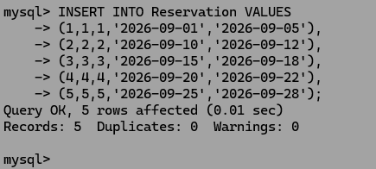

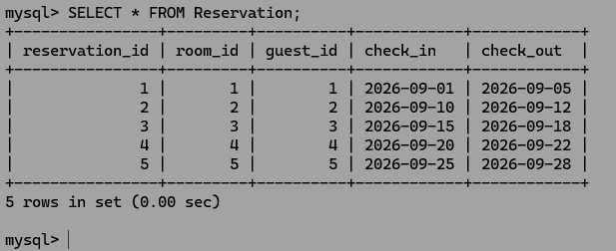

Payment table---------

INSERT INTO Payment VALUES
-> (1,1,600.00,'2026-09-01','Credit Card'),
-> (2,2,500.00,'2026-09-10','Cash'),
-> (3,3,270.00,'2026-09-15','Online'),
-> (4,4,160.00,'2026-09-20','Credit Card'),
-> (5,5,240.00,'2026-09-25','Debit Card');

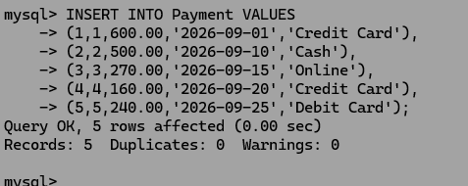

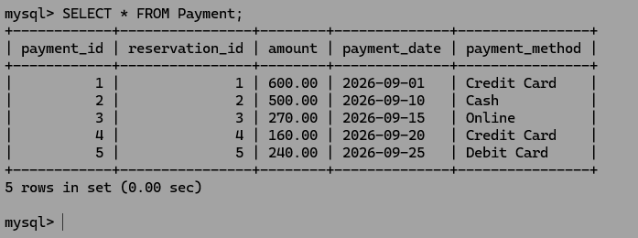

A.
1---
mysql> UPDATE Room
-> SET price_per_night = 175.00
-> WHERE room_number = '101';

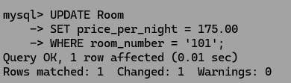
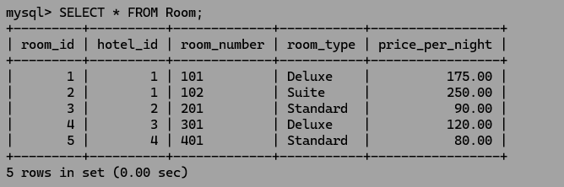

2---
UPDATE Guest
-> SET phone = '0701112233'
-> WHERE first_name = 'Carlos' AND last_name = 'Perera';
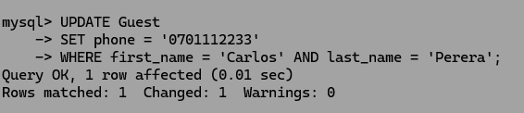
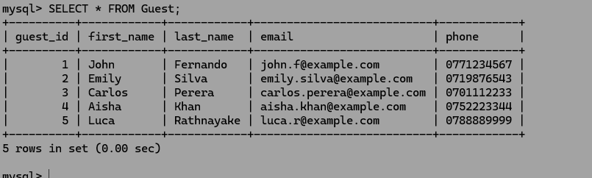

3------
UPDATE Payment
-> SET payment_method = 'Bank Transfer'
-> WHERE payment_id = 3;
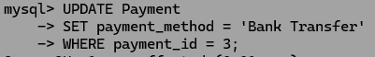
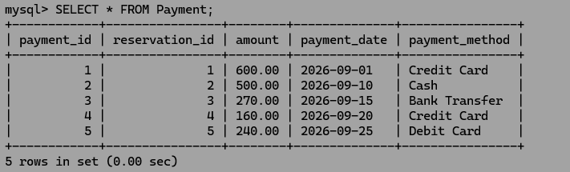

4---
DELETE FROM Payment
-> WHERE reservation_id = 5;
DELETE FROM Reservation
-> WHERE reservation_id = 5;

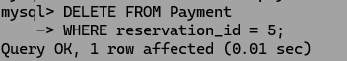
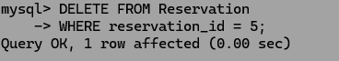
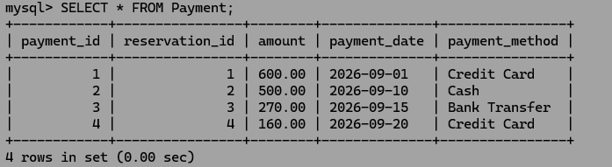
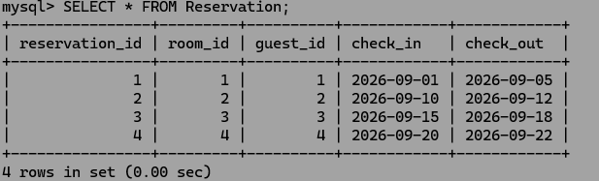
5----
DELETE FROM Payment
-> WHERE reservation_id=4;
DELETE FROM Reservation
-> WHERE guest_id=4;
DELETE FROM Guest
-> WHERE guest_id=4;

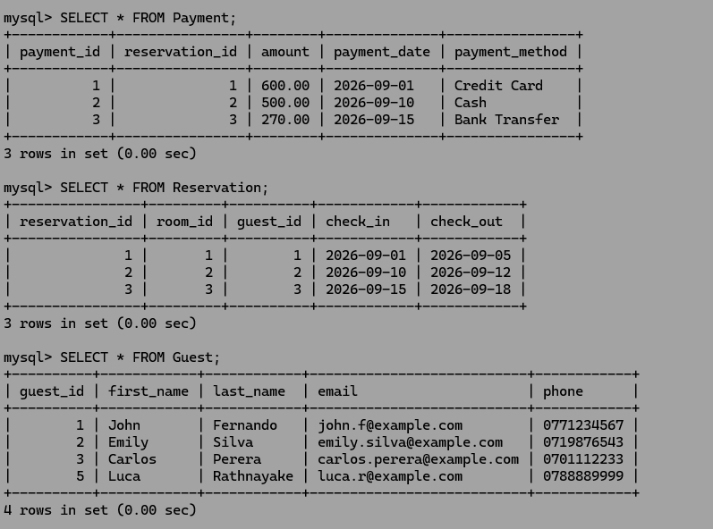

B.
1-----
ALTER TABLE Guest
-> ADD loyalty_points INT;
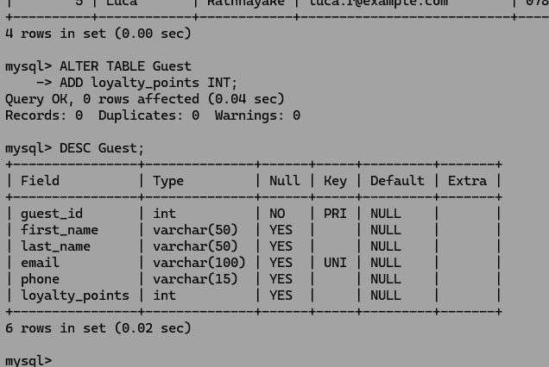

2----
ALTER TABLE Guest
-> RENAME COLUMN phone TO contact_number;
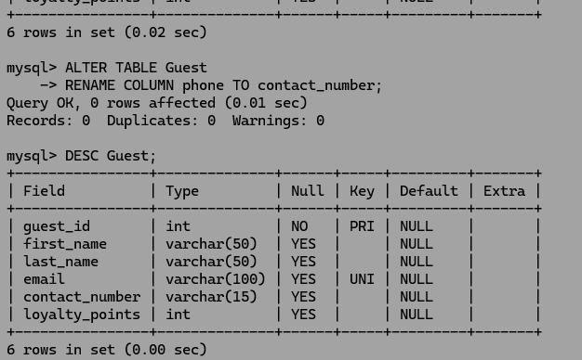
3----
ALTER TABLE Room
-> MODIFY COLUMN price_per_night DECIMAL(12, 2);
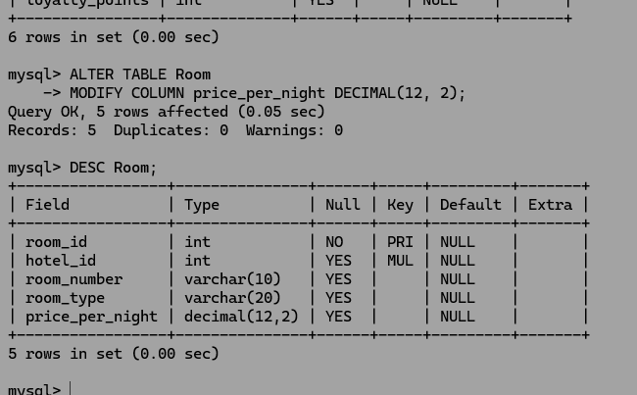

4----
ALTER TABLE Hotel
-> DROP COLUMN star_rating;
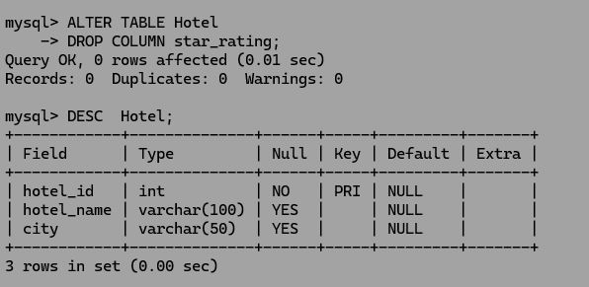

5----
ALTER TABLE Reservation
-> ADD COLUMN status VARCHAR(20);

